PARALLEL ADDER

1. 7 (0111) + 2(0010) = 9(1001)

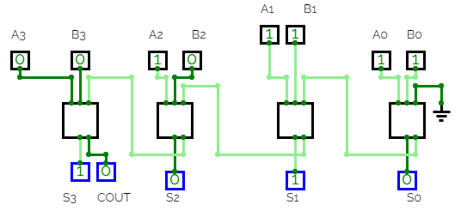

1. 7 (0111) + 10(1010) = 17(10001)

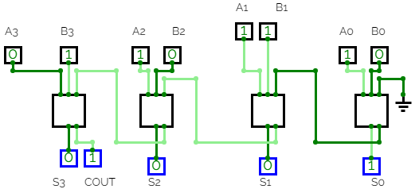

1. 10(1010) + 1(0001) = 11(1011) 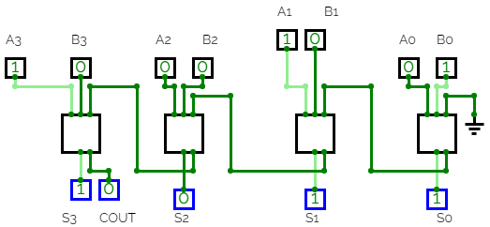
2. 10(1010) + 9(1001) = 19(10011)

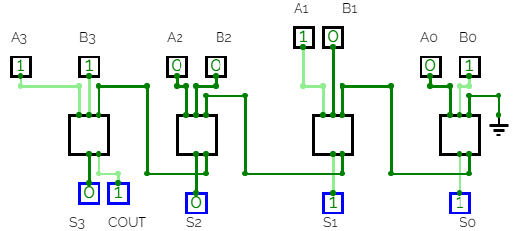

1. 15(1111) + 3(0011) = 18(10010)

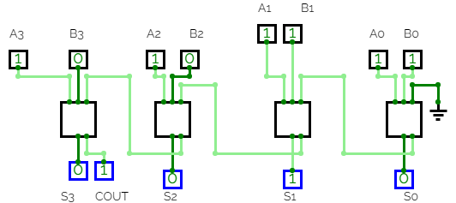

1. 15(1111) + 11(1011) = 26(11010)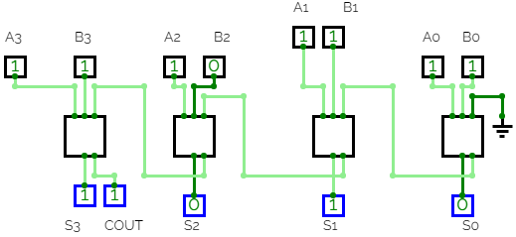

HENCE PARALLEL ADDER IS IMPLEMENTED.